Introduction
A common criticism levied against environmental educators like me is that we are “all doom and gloom.” After all, our primary function in academia is to bring awareness to the myriad environmental problems we have created for ourselves. Yet, it is extremely well-documented that, as environmental writer Stewart Brand once put it, “bad news bums people out.” Of course, it is probably an equally well-documented psychological phenomenon that “being bummed out” is an undesirable state to begin from when problem-solving. So, as an environmental educator pursuing a degree in rhetoric, I am eager to understand the nature of the subfield of Environmental Rhetoric as it exists today and how it may have changed recently (recently here is defined as the past decade from 2015 - 2025).

Since reading, studying, and analyzing every published article, dissertation, book, and conference proceeding under the umbrella of Environmental Rhetoric would be impossible, a different approach is necessary. Such an approach must be achievable on a time scale that is feasible, and it must produce an understanding of where the discipline has been, where it is now, and it must enable our ability to discern patterns of communication within the discipline. In short, we must develop a “sense” of Environmental Rhetoric, a “Network Sense.”

Muller defines Network Sense as “an epistemological capacity for discerning those patterns entangled with a broad set of forces running through and beyond the text, involving matters of semantic associations, historical orientations, locations, and relationships” (Mueller, 2017, p. 34). In other words, establishing a network sense of any discipline requires one to develop a mental representation, or as an analogy, a map, of the patterns of communication in the multitude of journals, conferences, graduate studies, news publications, and other information outlets, and just as importantly, to understand how those patterns change over time.

Given the depth, breadth, and variety of communications within any discipline, the complexity and intensity of building an all-inclusive map would be prohibitively time and resource intensive thus highlighting the need for a systematic methodology that allows one to develop not a map per se, but a “sense” of a map. Fortunately, Muller has developed such a methodology, and, in this paper, I will apply his methods to one subdiscipline of Rhetoric & Composition, Environmental Rhetoric.

Muller offers two distinct but complementary methods, Distant Reading and Thin Description. Distant Reading, a term first introduced by literary scholar Franco Moretti, is a method of observing a body of writing that allows one to “focus on units that are much smaller or much larger than the text: devices, themes, tropes—or genres and systems” (Muller, 2017, p. 25). Muller goes on to acknowledge this approach leads to a loss of information by stating, “If we want to understand the system in its entirety, we must accept losing something.”

Thick Description is a foundational concept in qualitative research across the social sciences. It is an approach to data gathering that captures not just observable details and relevant facts, but also their meanings, interpretations, and as much context as possible. This is, of course, not possible when reading at a distance. As Muller notes, Thin Description, “trades the depth of interpretive richness for breadth and relational patterning; it privileges surfaces and structures over depths and intentions, offering a way to describe disciplinary activity at scale” (Muller, 2017, p. 27).

When applied together to a representative corpus, Distant Reading and Thin Description are complementary methods that allow one to develop the ability to recognize and understand patterns and connections within disciplinary knowledge. In this project, a representative corpus of Environmental Rhetoric over the past decade was assembled and evaluated using Muller’s methods. Distant Reading and Thin Description were accomplished by evaluating only the titles, keywords, and, where available, abstracts of the literature comprising the corpus.

Initially, I hoped to answer the following four questions:

1. What environmental problems are being addressed in the subfield of Environmental Rhetoric today?
2. Has there been a shift in coverage or emphasis of environmental topics by rhetoricians over the past decade?
3. To what extent has environmental rhetoric of the past decade been optimistic, solution-oriented, or hopeful?
4. To what extent has environmental rhetoric of the past decade been pessimistic, crisis-oriented, or alarmist?

As I came to more fully understand the value and utility of developing a Network Sense of Environmental Rhetoric, I became confident that I could answer the first two questions. However, as my understanding grew, so did my doubt that I would be able to answer the last two. In fact, now having completed the assembly of the corpus and its analysis, it is clear that Distant Reading and Thin Description to not easily nor readily allow one to discern the tone of a particular piece. This would seem a limitation of Muller’s approach, but as he stated, we must be prepared to lose something.

Methods & Data
Ultimately, three sets of data were generated to serve as the basis of this analysis.

First, using only my instincts and experience as a guide, I visited the UCF Library (virtually) where I collected my first set of data (“Library Data”) by conducting individual keyword searches for the following terms using the UCF Library’s “Primo” search:

- “Ecocomposition AND Rhetoric”
- “Ecocriticism AND Rhetoric”
- “Ecological AND Rhetoric”
- “Environment AND Rhetoric”
- “Nature AND Rhetoric”

Searching for the five terms listed above generated 318 unique entries of the following types:

- Books
- Book Chapters
- Book Reviews
- Articles (Scholarly and Research)
- Conference Proceedings
- Dissertations

After eliminating all entries for books, book chapters, and book reviews, I was left with a total of 181 Articles, Conference Proceedings, and Dissertations. Admittedly, my list of search terms was not exhaustive so there are almost certainly other published works available to me that were missed in this limited effort. For example, I might also have searched for terms such as, “Ecology and Rhetoric,” and “Environmentalism and Rhetoric,” etc.

Also, it should be noted that not all content available via the UCF Library is accessible via the Primo search function. So, another opportunity to improve the data set (and this analysis) would be to search the many relevant, individual databases, separately and directly. Since this is just one project in just one class, and in the spirit of reading at a distance and describing thinly, I opted for the efficient and pragmatic path and did not conduct a “dissertation-level” literature search.

For each of the remaining 181 entries, I gathered their Titles, Author Name(s), and all available metadata (Journal Name, Volume Number, Issue Number, Publication Date, Keywords, DOI Number, Direct URL, and wherever possible, Abstracts and/or Summaries) in an Excel workbook. It was at this point that I was advised to shift my data gathering efforts away from the library and toward articles collected directly from journals. So, I selected the two journals I was familiar with as I had already confirmed them to be reputable sources of Environmental over the past decade.

I did that and will discuss it next; however, it would become clear later in the course of this project that revisiting the Library Data and using it to build visualizations for comparison to the visualizations built on journal data would provide some much-needed insights.

In a previous assignment for this course (Forum Analysis), I had relied on a combination of internet searching (Google) and class resources (Student Example Work) to choose two academic organizations publishing Nature Rhetorics:

- "The International Environmental Communication Association (IECA) is a professional nexus of practitioners, teachers, scholars and researchers, students, artists and organizations engaged in the study and practice of environmental communication." Their journal is called Environmental Communication (EC).
- "The Association for the Study of Literature and Environment (ASLE) seeks to inspire and promote intellectual work in the environmental humanities and arts. Our vision is an inclusive community whose members are committed to environmental research, education, literature, art and service, environmental justice, and ecological sustainability." Their journal is called Interdisciplinary Studies in Literature & Environment (ISLE).

Upon completing the assigned analysis, I found I had developed a strong sense of both journals and determined them to be highly relevant to my interests in Environmental Rhetoric. Since I am not interested (at this point) in constructing or even visualizing a deep history of Environmental Rhetoric and am only keen to build a network sense of its current landscape, I opted to build a second data set (“Journal Data 1”) by selecting one issue from each journal for each of three years: current (2025), the recent past (2020), and the distant past (2015). Since EC runs eight issues per year on a fixed cadence, and since ISLE is published seasonally four times per year, picking the April issues of EC and Spring issues of ISLE provided close alignment across years.

The following is the list of journals that were used to build the “Journal Data 1” data set:

- EC – 2015: Volume 9, Number 2, April 3, 2015
- EC – 2020: Volume 14, Number 3, April 2, 2020
- EC – 2025: Volume 19, Number 3, April 3, 2025
- ISLE – 2015: Volume 22, Issue 2, Spring 2015
- ISLE – 2020: Volume 27, Issue 2, Spring 2020
- ISLE – 2025: Volume 32, Issue 1, Spring 2025

At this point, I realized this project demanded the use of generative AI for creating visualizations, so I went “all in” and began to leverage those resources heavily. First, I prompted ChatGPT (v5.0) to scrape Oxford University Press’ and Ingenta’s websites to extract the desired data from each of these six journal issues. Each article’s title, author name(s), keywords (if available), abstract (if available), and other relevant metadata were compiled in a spreadsheet. After eliminating book reviews, editorials, and any article not deemed “Scholarly” or “Research,” 45 articles remained and would serve as the basis of my first attempts at visualizing.

Having already gotten comfortable with ChatGPT’s interface and recognizing its power, I asked ChatGPT how it could go about making word clouds for me. The recommendation was to have ChatGPT generate code written in Python that I would be able to copy and paste into Google CoLab, a free online Python compiler. In hindsight, this was a bad, but valuable, move. This step required a lot of time error checking and greatly slowed my progress on this project. It took many iterations of this step to allow ChatGPT to produce a Python script that produced appropriate word clouds. However, I have learned more about ChatGPT than I ever did, including ways to utilize it to streamline my workflow as an educator.

The first attempt at visualizing the “Journal Data 1” data set is seen below in Figure 1.

Figure 1
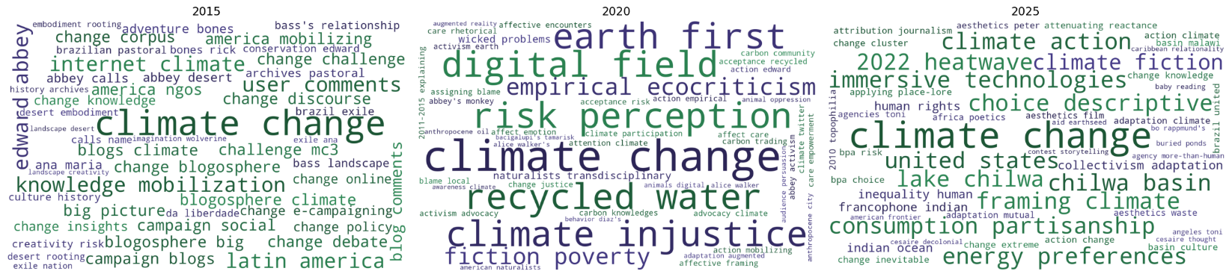

I was dissatisfied with the result. First, there were too many words – everything was represented, yet I felt not everything merited representation. Second, there was no way to visualize what content came from which journal, not a necessary requirement, but given the differences between the journals (EC publishes research while ISLE publishes scholarly work plus creative writing and poetry), I felt this would be valuable to see. Third, I felt the range of font sizes made some terms too dominant and some barely legible. So, I began revising my prompts and regenerating code in ChatGPT that I would then paste again into CoLab. Eventually, after many hours of annoyance, I came up with Figure 2:

Figure 2
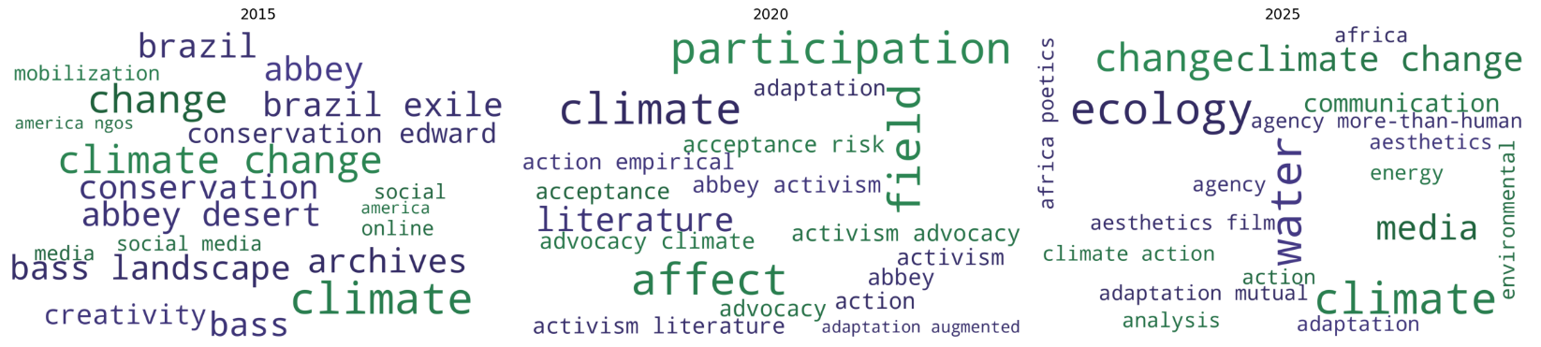

Reading through the article titles, abstracts, and keywords compiled was not too challenging since this approach only yielded 45 data points. In doing so, I was able to determine with a fairly strong sense of confidence that Figure 2 is representative of the importance of each term (as determined by frequency of appearance in the corpus). As anticipated, climate and climate change loom large in the literature. However, I was surprised that the terms “Artificial Intelligence” and “AI” were entirely absent. This was my impetus to expand the scope of the assembled corpus beyond six journal issues.

The following is the list of journals that were used to build my third data set, “Journal Data 2.” Note that a Summer issue of ISLE was selected for 2025 since the Autumn issue was a special issue with a singular editorial focus.

- EC – 2015: Vol. 9, Number 4, October 2, 2015
- EC – 2020: Vol. 14, Number 7, October 2, 2020
- EC – 2025: Vol. 19, Number 6, August 18, 2025
- ISLE – 2015: Vol. 22 Issue 4, Autumn 2015
- ISLE – 2020: Vol. 27 Issue 4, Autumn 2020
- ISLE – 2025: Vol. 32 Issue 3, Summer 2025

I will explain my interpretations of the following images (generated on wordcloud.com) in my next draft including a discussion of the rationale for revisiting the data set first compiled, “Library Data.” I also intend to add visualizations depicting topics of dissertations in the field during 2015 – 2025. Furthermore, I am considering what different visualizations I might employ to identify any apparent trends (though I am not detecting anything significant, only subtle, as of this writing.) Also, I should note that I tend to write a paper first and then present it via Power Point. In other words, this is far from this document’s final form and should be considered more of a “working copy” than it is a “first draft.”

ISLE and EC combined Keywords 2015
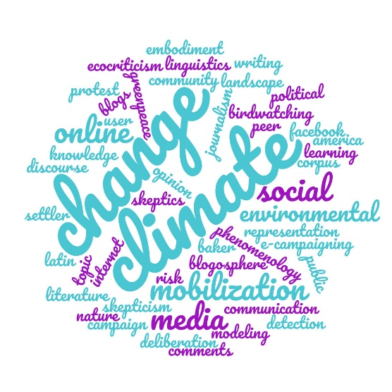
ISLE and EC combined Keywords 2020
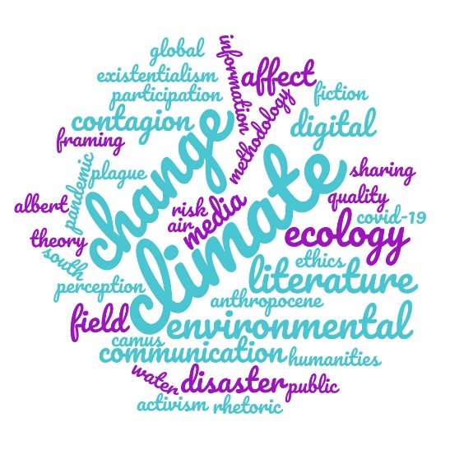
ISLE and EC combined Keywords 2025
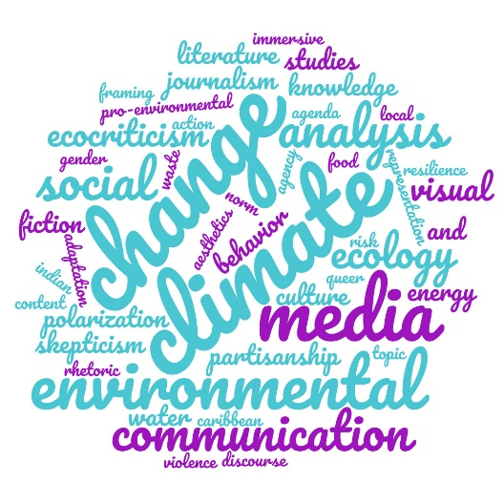

ISLE and EC combined Titles 2015
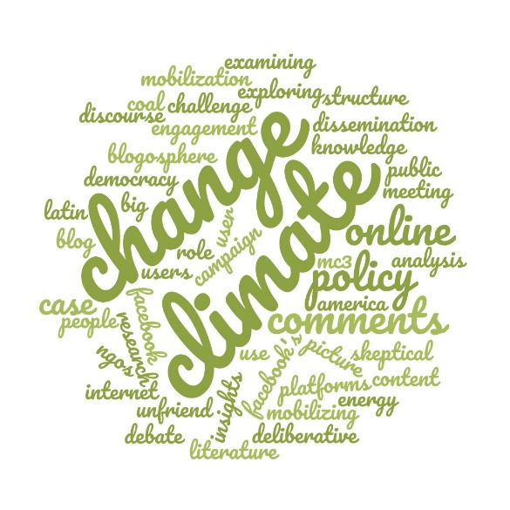
ISLE and EC combined Titles 2020
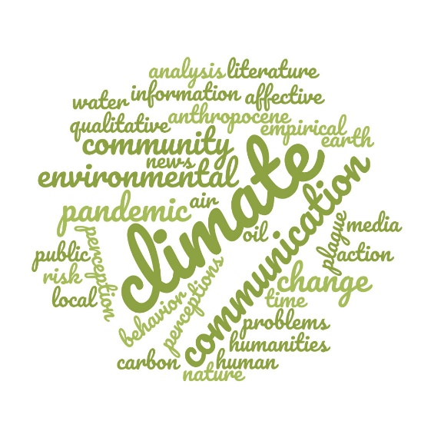
ISLE and EC combined Titles 2025
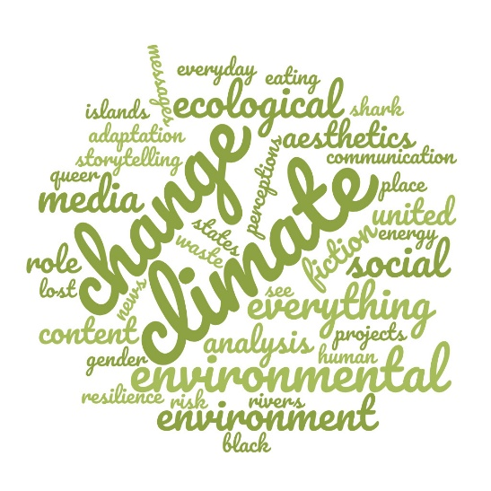
Library Search Keywords 2013 – 2017

Library Search Keywords 2018 – 2022
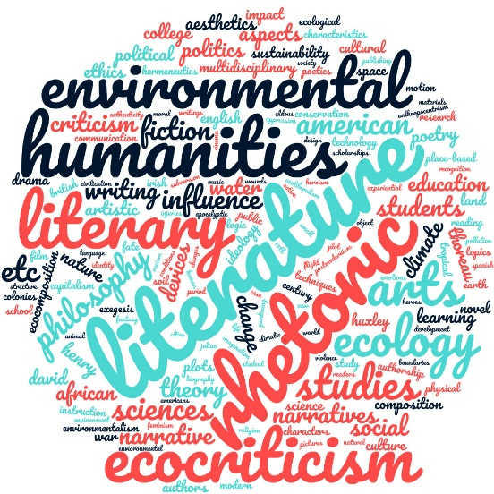
Library Search Keywords 2023 – 2025

Library Search Titles 2013 – 2017
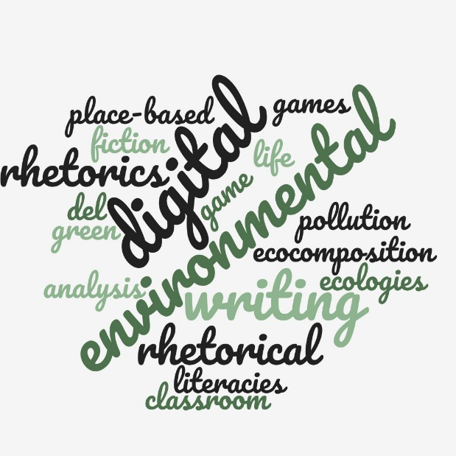
Library Search Titles 2018 – 2022
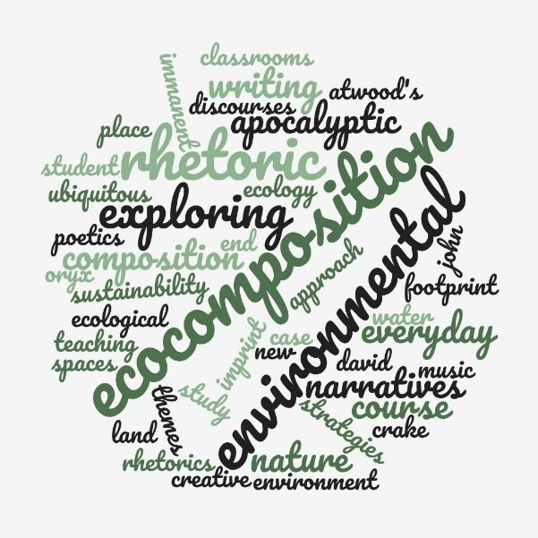
Library Search Titles 2023 – 2025
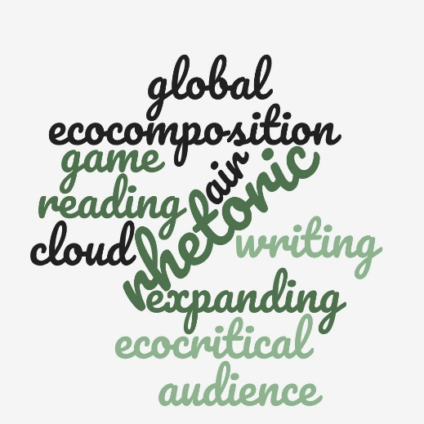

References

Environmental Communication. (2015, April 3). Vol. 9(2).
Environmental Communication. (2020, April 2). Vol. 14(3).
Environmental Communication. (2025, April 3). Vol. 19(3).
Environmental Communication. (2015, October 2). Vol. 9(4).
Environmental Communication. (2020, October 2). Vol. 14(7).
Environmental Communication. (2025, August 18). Vol. 19(6).
ISLE: Interdisciplinary Studies in Literature and Environment. (2015, Spring). Vol. 22(2).
ISLE: Interdisciplinary Studies in Literature and Environment. (2020, Spring). Vol. 27(2).
ISLE: Interdisciplinary Studies in Literature and Environment. (2025, Spring). Vol. 32(1).
ISLE: Interdisciplinary Studies in Literature and Environment. (2015, Autumn). Vol. 22(4).
ISLE: Interdisciplinary Studies in Literature and Environment. (2020, Autumn). Vol. 27(4).
ISLE: Interdisciplinary Studies in Literature and Environment. (2025, Summer). Vol. 32(3).
Mueller, D. N. (2017). Network sense: Methods for visualizing a discipline. WAC Clearinghouse; University Press of Colorado. https://doi.org/10.37514/PER-B.2017.0919

Appendix

Python Code Generated by ChatGPT for use in Google CoLab

Setup Code:

# --- SETUP BLOCK ---

!pip install pandas matplotlib wordcloud scikit-learn nltk

import pandas as pd
import numpy as np
import matplotlib.pyplot as plt
from wordcloud import WordCloud
from sklearn.feature_extraction.text import CountVectorizer
from nltk.corpus import stopwords
import nltk
nltk.download("stopwords")

# English stopwords
stop_words = set(stopwords.words("english"))

print("Setup complete ✅")

Generative Code:

# --- WORD CLOUD GENERATION (EC=green, ISLE=blue, OTHER=red) ---

from matplotlib.colors import LinearSegmentedColormap

# === Load your workbook ===
# Tip: in Colab, upload the file (left sidebar > Files) and set this path accordingly:
file_path = "/content/MCGINNIS_Network_Sense_Mapping_Data.xlsx" # <-- change if needed
df = pd.read_excel(file_path)

# === Column normalization ===
# Required columns: Title, Keywords, Source, Year
for col in ["Title", "Keywords", "Source", "Year"]:
if col not in df.columns:
raise ValueError(f"Missing required column: {col}")

df["Title"] = df["Title"].fillna("").astype(str)
df["Keywords"] = df["Keywords"].fillna("").astype(str)
df["Source"] = df["Source"].fillna("").astype(str)
df["Year"] = df["Year"].astype(str)

# === Helper: safe ngram frequencies ===
def ngram_freqs(texts, ngram_range=(1,2), top_n=10, min_df=1, max_df=1.0):
texts = [t for t in texts if isinstance(t, str) and t.strip() != ""]
if len(texts) == 0:
return []
try:
vec = CountVectorizer(
stop_words=list(stop_words),
ngram_range=ngram_range,
min_df=min_df,
max_df=max_df
)
X = vec.fit_transform(texts)
except ValueError:
# Fallback for tiny corpora
vec = CountVectorizer(
stop_words=list(stop_words),
ngram_range=(1,1),
min_df=1,
max_df=1.0
)
X = vec.fit_transform(texts)
freqs = X.sum(axis=0).A1
terms = vec.get_feature_names_out()
pairs = sorted(zip(terms, freqs), key=lambda x: x[1], reverse=True)
return pairs[:top_n]

# === Define groups by Source ===
def is_ec(s): return "ec" in s.lower()
def is_isle(s): return "isle" in s.lower()

# Colors
green_map = LinearSegmentedColormap.from_list("green_map", ["#8FD19E","#2A6E3F"]) # EC
blue_map = LinearSegmentedColormap.from_list("blue_map", ["#9DBDE0","#254A7A"]) # ISLE
red_map = LinearSegmentedColormap.from_list("red_map", ["#F5A3A3","#8C1D1D"]) # OTHER

# Parameters
years = ["2015", "2020", "2025"]
TOP_PER_GROUP = 10 # 10 EC + 10 ISLE + 10 OTHER = 30 max words per cloud
NGRAMS = (1,2)

for year in years:
# Partition by source
mask_year = df["Year"] == year
df_year = df[mask_year]

df_ec = df_year[df_year["Source"].apply(is_ec)]
df_isle = df_year[df_year["Source"].apply(is_isle)]
df_other= df_year[~df_year["Source"].apply(is_ec) & ~df_year["Source"].apply(is_isle)]

# Build corpora from Keywords + Title
texts_ec = (df_ec["Keywords"] + " " + df_ec["Title"]).tolist()
texts_isle = (df_isle["Keywords"] + " " + df_isle["Title"]).tolist()
texts_other = (df_other["Keywords"] + " " + df_other["Title"]).tolist()

# Top terms per group
ec_freq = ngram_freqs(texts_ec, ngram_range=NGRAMS, top_n=TOP_PER_GROUP)
isle_freq = ngram_freqs(texts_isle, ngram_range=NGRAMS, top_n=TOP_PER_GROUP)
other_freq = ngram_freqs(texts_other, ngram_range=NGRAMS, top_n=TOP_PER_GROUP)

# Merge into one frequency dict (keep group membership for colors)
freq_dict = {}
group_map = {} # term -> group label
for term, f in ec_freq:
freq_dict[term] = f
group_map[term] = "EC"
for term, f in isle_freq:
# If a term overlaps, keep the larger freq and prefer its group color
if term not in freq_dict or f > freq_dict[term]:
freq_dict[term] = f
group_map[term] = "ISLE"
for term, f in other_freq:
if term not in freq_dict or f > freq_dict[term]:
freq_dict[term] = f
group_map[term] = "OTHER"

if not freq_dict:
print(f"No terms for {year}. Skipping.")
continue

# Color function based on group
def color_func(word, *args, **kwargs):
g = group_map.get(word, "OTHER")
if g == "EC":
return green_map(np.random.rand())
elif g == "ISLE":
return blue_map(np.random.rand())
else:
return red_map(np.random.rand())

# Generate and display
wc = WordCloud(
width=1200, height=700,
max_words=len(freq_dict),
background_color="white",
prefer_horizontal=0.9,
colormap=None # use our custom color_func
).generate_from_frequencies(freq_dict)

plt.figure(figsize=(10,6))
plt.imshow(wc.recolor(color_func=color_func, random_state=8), interpolation="bilinear")
plt.axis("off")
plt.title(f"Top Title+Keyword Terms by Source — {year}\nEC=green, ISLE=blue, Other=red", fontsize=18)
plt.show()

print("Done ✅")

